MindNeedAI: Comprehensive System Documentation

Executive Summary
MindNeedAI is an ethically-driven, AI-powered mental wellness companion platform designed specifically for senior populations. The system leverages multimodal artificial intelligence to analyze emotional states through text, speech, and facial expressions, providing personalized care recommendations and facilitating clinical oversight through integrated healthcare provider workflows.
Built on a modern microservices-oriented architecture, MindNeedAI combines real-time emotion detection, clinical assessment tools, emergency alert systems, and therapeutic content recommendations into a cohesive platform that balances technological sophistication with human-centered care principles. The platform operates under strict privacy-by-design principles, ensuring all sensitive data is encrypted and user consent is managed transparently throughout the system.

System Architecture

High-Level Architecture
MindNeedAI follows a modular, service-oriented architecture pattern that separates concerns across distinct functional domains. The system consists of three primary layers: a React-based frontend application, a FastAPI-powered backend API layer, and a PostgreSQL database with SQLite fallback for development environments.
The backend architecture is organized into domain-specific modules, each handling a distinct aspect of the platform's functionality. This modular approach enables independent development, testing, and scaling of individual components while maintaining clear interfaces between services. The system employs dependency injection patterns throughout, ensuring loose coupling and high testability.

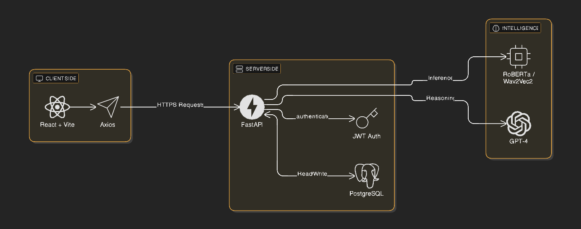
Core Architectural Principles
Separation of Concerns: Each module maintains a single, well-defined responsibility. Analysis services handle only emotion detection, recommendation services manage content selection, and the core API layer orchestrates interactions between components without embedding business logic.
Privacy by Design: Data encryption occurs at the point of ingestion. User text inputs are encrypted using Fernet (AES-128) before storage, and all sensitive operations require explicit consent tokens. The system never stores plain-text user communications, even in logs.
Human-in-the-Loop Integration: Critical decisions are augmented, not replaced, by AI. The system employs intelligent review triggers that route high-risk or low-confidence analyses to clinical reviewers, maintaining a clear separation between automated assistance and professional judgment.
Continuous Learning: The platform incorporates feedback loops that allow clinical reviewers to correct AI assessments. These corrections are aggregated and used to fine-tune models periodically, ensuring the system improves over time while maintaining strict privacy controls.

Core Features and Modules

Multimodal Emotion Analysis
The platform's primary capability lies in its ability to analyze emotional states through three distinct modalities, each providing complementary insights into a user's mental wellness.

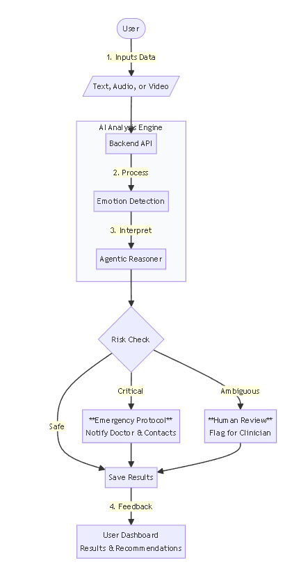

Text Analysis Module
Users can express their thoughts and feelings through written text, which is processed through a dual-layer AI architecture. The first layer employs a fine-tuned RoBERTa model to perform rapid sentiment classification, categorizing input as positive, neutral, or negative with confidence scores. The second layer utilizes GPT-4 to conduct deep clinical risk assessment, evaluating factors such as depression indicators, anxiety markers, social isolation, and suicide risk. The system validates consistency between these analyses and generates a weighted review trigger score that determines whether human clinical review is necessary.

Video Analysis Module
Real-time facial emotion detection captures and analyzes video streams from user webcams. The system employs MediaPipe for face detection and a ResNet50-based model for emotion classification across seven emotional states: happiness, sadness, anger, fear, disgust, surprise, and neutral. An optional LSTM model provides temporal smoothing to track emotional transitions over time. Every frame is logged to the database, ensuring complete session history. After session completion, the system aggregates frame-level data and performs pattern analysis using GPT-4 to identify concerning emotional patterns and generate care recommendations.

Speech Analysis Module
Audio recordings are processed using a Wav2Vec2-based emotion recognition model that analyzes vocal patterns, tone, and speech characteristics to detect eight distinct emotions. The system evaluates audio quality, speech coherence, and emotional stability throughout the recording. Similar to other analysis modules, the speech analysis integrates with the agentic reasoning system to provide clinical insights and risk assessments based on vocal patterns.

Clinical Assessment System

The platform includes a comprehensive clinical assessment workflow that enables healthcare providers to request standardized mental health questionnaires from their patients.

Assessment Request Workflow
Doctors can create assessment requests for connected patients, specifying either PHQ-9 (depression screening) or GAD-7 (anxiety screening) questionnaires, or both. Each request includes an expiration date and optional notes for the patient. The system prevents duplicate pending requests and validates doctor-patient relationships before allowing request creation

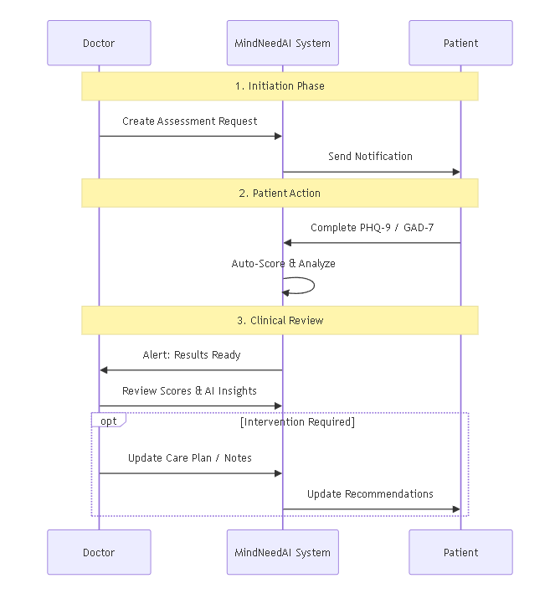

Patient Assessment Interface
Patients receive notifications when assessment requests are available and can complete questionnaires through an intuitive interface. The system enforces that patients cannot view their own results directly, maintaining clinical oversight. Upon submission, responses are automatically scored using validated clinical algorithms, and results are immediately available to the requesting doctor.

Assessment Results Management
Doctors can view comprehensive assessment results including severity classifications, treatment recommendations, and historical trends for each patient. The system maintains complete assessment history, enabling longitudinal tracking of patient mental health status over time.

Mental Wellness Form System
A flexible form management system allows doctors to create, manage, and review structured mental wellness assessments for their patients. Forms can be created as drafts, submitted for patient completion, and reviewed after submission. The system includes AI-powered insights generation that analyzes form responses to identify patterns and generate preliminary clinical observations, which doctors can review and incorporate into their professional assessments.

Emergency Alert System
An intelligent emergency detection and notification system monitors all analysis results for critical risk indicators. The system evaluates care urgency levels and suicide risk scores from agentic analyses, triggering alerts only when genuine emergency conditions are detected. A cooldown mechanism prevents alert fatigue by enforcing minimum intervals between notifications. When triggered, the system retrieves the user's configured emergency contacts (doctors and loved ones) and sends detailed alert emails containing context about the detected risk, analysis type, and recommended actions.

Therapeutic Content Recommendations

Three complementary recommendation systems provide personalized therapeutic content based on detected emotional states.

Music Recommendation Service
Curated music libraries organized by emotion category provide therapeutic audio content. The system tracks user play history to ensure variety and employs deterministic selection algorithms to maintain consistency within sessions while preventing repetition.

Video Recommendation Service
Local video libraries containing therapeutic content such as nature scenes, meditation guides, and relaxation exercises are recommended based on emotional state. The system manages play history and ensures users experience diverse content over time.

YouTube Recommendation Service
An intelligent YouTube integration recommends validated therapeutic videos including meditation sessions, breathing exercises, and nature therapy content. The system includes content validation to ensure recommended videos meet quality and appropriateness standards for therapeutic use.

Mood Tracking System
A simple yet effective mood tracking feature allows users to record daily mood scores on a scale of one to ten, accompanied by optional notes. The system provides calendar views, weekly overviews, and trend analysis to help users and their healthcare providers understand mood patterns over time.

Doctor-Patient Relationship Management
The platform facilitates secure connections between patients and healthcare providers through a unique code-based system. Doctors generate connection codes that patients can use to establish relationships. Once connected, doctors gain access to their patients' analysis history, assessment results, and wellness forms, enabling comprehensive care coordination.

Notification System
A comprehensive notification framework keeps users informed about assessment requests, analysis completions, review statuses, and system updates. Notifications are delivered through the application interface and can be managed through user preferences.

Technical Implementation

Backend Technology Stack
The backend is built on FastAPI, a modern Python web framework that provides automatic API documentation, async/await support, and high performance. The system uses SQLAlchemy as the ORM layer, supporting both PostgreSQL for production and SQLite for development environments. Database connection pooling is configured to optimize performance under load.
Authentication is implemented using JWT (JSON Web Tokens) with configurable expiration times. The system maintains separate authentication flows for users and doctors, with role-based access control enforced at both the API and frontend levels. Rate limiting is applied to authentication endpoints to prevent brute-force attacks, and login attempt tracking provides account lockout functionality.

Frontend Technology Stack
The frontend is a single-page application built with React and TypeScript, providing type safety and modern development tooling. The application uses React Router for client-side routing, with protected routes that enforce authentication and role-based access. State management is handled through React Context API, with separate contexts for authentication, theme preferences, notifications, and sidebar state.
The UI is built with Tailwind CSS, providing a consistent design system and responsive layouts. The application includes comprehensive error boundaries, loading states, and user feedback mechanisms to ensure a smooth user experience.

AI and Machine Learning Infrastructure
Model Management: All AI models are managed through a centralized model registry system that tracks versions, performance metrics, and deployment status. Models are cached locally to reduce inference latency, and the system supports model versioning to enable A/B testing and gradual rollouts.
Model Preloading: During application startup, all required models are preloaded into memory to eliminate cold-start delays. This includes text analysis models (RoBERTa), video analysis models (ResNet50, LSTM), and speech analysis models (Wav2Vec2).
Continuous Learning Pipeline: The system collects expert feedback from clinical reviewers who correct AI assessments. This feedback is aggregated and used to fine-tune models periodically. The training pipeline respects user consent, using only data from users who have explicitly consented to model training.

Data Privacy and Security
Encryption: All sensitive user data, including text inputs and analysis metadata, is encrypted using Fernet (symmetric encryption based on AES-128). Encryption keys are derived using PBKDF2 with 100,000 iterations and a configurable salt. The system never stores plain-text user communications.
Consent Management: Users must provide explicit consent for data storage and model training. Consent is managed through encrypted tokens that include timestamps and user identifiers. Users can withdraw consent at any time, triggering immediate data deletion.
Audit Logging: All system actions are logged to an audit trail, including user authentications, data access, analysis requests, and administrative actions. Logs are structured to support compliance requirements and security investigations.
Data Retention: Configurable retention policies govern how long different types of data are stored. Analysis results may be retained for 30 days, while user feedback and training data may be retained longer to support model improvement.

User Workflows

Patient User Journey
A typical patient journey begins with account registration, where users provide basic information and establish authentication credentials. Upon first login, users are guided through an onboarding process that explains the platform's capabilities and privacy practices.
Users can engage with the platform through multiple analysis modalities. They might start by writing about their day in the text analysis interface, receiving immediate feedback about their emotional state and personalized care recommendations. The system may recommend therapeutic music or videos based on the detected emotion, creating a holistic wellness experience.
For users with connected doctors, assessment requests appear as notifications. Patients complete these assessments through an intuitive questionnaire interface, receiving confirmation upon submission while results are automatically routed to their healthcare provider.
The mood tracking feature allows users to maintain a daily wellness journal, recording mood scores and optional notes. Over time, users can review their mood trends through calendar and chart visualizations, gaining insights into their emotional patterns.

Healthcare Provider Workflow
Doctors begin by registering and verifying their credentials. Once registered, they generate connection codes that patients can use to establish care relationships. The doctor dashboard provides a comprehensive view of all connected patients, including recent analysis activity, assessment results, and wellness form submissions.
When a doctor identifies a need for clinical assessment, they create assessment requests specifying the type of questionnaire (PHQ-9 or GAD-7) and optional notes for the patient. The system manages request expiration and prevents duplicate requests, ensuring efficient workflow management.
Doctors can review patient analysis history, including text, video, and speech analysis results that have been flagged for review. The review interface presents AI-generated summaries alongside original analysis data, allowing doctors to provide professional judgment and corrections that feed back into the continuous learning system.
The mental wellness form system enables doctors to create structured assessments tailored to specific patient needs. Forms can be created as drafts, shared with patients for completion, and reviewed with AI-generated insights to support clinical decision-making.

Clinical Reviewer Workflow
Clinical reviewers access a specialized interface that presents cases requiring human review. The system prioritizes cases based on risk scores, confidence levels, and urgency indicators. Reviewers examine AI-generated assessments, original user inputs (when consent is provided), and analysis metadata to make professional judgments.
Reviewers can correct AI classifications, adjust confidence scores, and provide detailed notes explaining their assessments. These corrections are stored and aggregated for model fine-tuning, creating a feedback loop that improves system accuracy over time.

Integration Points and Extensibility

API Architecture
The system exposes a comprehensive RESTful API with automatic OpenAPI documentation available at the `/docs` endpoint. All endpoints follow consistent patterns for authentication, error handling, and response formatting. The API is designed to support future mobile applications, third-party integrations, and automated workflows.

Email Integration
The platform integrates with SMTP email services to deliver emergency alerts, assessment request notifications, and system communications. Email configuration is environment-based, supporting various SMTP providers and authentication methods.

Model Integration Framework
The AI model architecture is designed to support easy integration of new models. The model manager provides a standardized interface for loading, versioning, and switching between model implementations. This enables the system to incorporate improved models as they become available without requiring extensive code changes.

Database Schema Evolution
The database schema is managed through SQLAlchemy migrations, enabling controlled evolution of data structures. The system maintains backward compatibility where possible and provides migration scripts for schema updates.

Performance and Scalability

Considerations

Optimization Strategies
The system employs several optimization strategies to ensure responsive performance. Model preloading eliminates cold-start delays, and model caching reduces repeated loading overhead. Database queries are optimized with appropriate indexes, and connection pooling manages database resource utilization efficiently.

Scalability Architecture
The modular architecture supports horizontal scaling of individual components. Analysis services can be scaled independently based on demand, and the stateless API design enables load balancing across multiple instances. Database read replicas can be introduced to distribute query load as the user base grows.

Resource Management
The system includes response size limits to prevent excessive data transfer, and rate limiting protects against abuse. Background task processing handles time-intensive operations like email sending and AI analysis generation, ensuring API responsiveness.

Quality Assurance and Safety Mechanisms

Review Trigger Logic
The system employs sophisticated algorithms to determine when human review is necessary. Review triggers consider multiple factors including AI confidence levels, risk severity scores, multiple concurrent concerns, signal quality, and protective factors. This multi-factor approach balances sensitivity with reviewer capacity, targeting a review rate of 12-18% of cases.

Emergency Detection
Emergency conditions are detected through careful evaluation of care urgency levels and suicide risk scores. The system employs conservative thresholds to ensure genuine emergencies are identified while minimizing false positives. Cooldown mechanisms prevent alert fatigue from repeated notifications.

Data Validation
Comprehensive input validation occurs at API boundaries, ensuring data integrity and preventing injection attacks. The system validates assessment responses, user inputs, and configuration parameters before processing.

Error Handling
The system implements consistent error handling patterns across all modules. Errors are logged with appropriate context, and user-facing error messages are sanitized to prevent information leakage while providing helpful feedback.

Future Considerations and Roadmap

Potential Enhancements
The platform's architecture supports several potential enhancements. Multi-language support could be added through model fine-tuning and translation services. Mobile applications could leverage the existing API to provide native iOS and Android experiences. Integration with electronic health record systems would enable seamless data exchange with existing healthcare infrastructure.

Model Improvement Opportunities
As the continuous learning system collects more expert feedback, model accuracy should improve over time. The platform could incorporate additional emotion detection models, explore ensemble methods for improved accuracy, and develop specialized models for senior populations.

Clinical Workflow Enhancements
Future versions could include appointment scheduling, medication tracking, and care plan management features. Integration with telehealth platforms would enable video consultations directly within the system.

Analytics and Reporting
Advanced analytics capabilities could provide population-level insights while maintaining individual privacy. Trend analysis, outcome tracking, and effectiveness metrics would support evidence-based care delivery.

Conclusion
MindNeedAI represents a comprehensive approach to AI-assisted mental wellness care, combining sophisticated technology with human-centered design principles. The platform's modular architecture, privacy-first approach, and continuous learning capabilities position it as a scalable solution for supporting senior mental health through technology.
The system's emphasis on human oversight, clinical integration, and ethical data handling ensures that AI serves as an augmentation tool rather than a replacement for professional judgment. This balance between technological capability and human care creates a platform that can grow and adapt while maintaining trust and safety as core principles.
Through its multimodal analysis capabilities, clinical assessment tools, and therapeutic content recommendations, MindNeedAI provides a holistic approach to mental wellness that respects user autonomy while facilitating professional care coordination. The platform's design supports both independent use by seniors and integrated care delivery through healthcare providers, making it a versatile tool for addressing the mental health needs of aging populations.

